**Hackathon Day 5**

**Testing, Error Handling and Backend Integration Refinement**

**Performance Testing:**

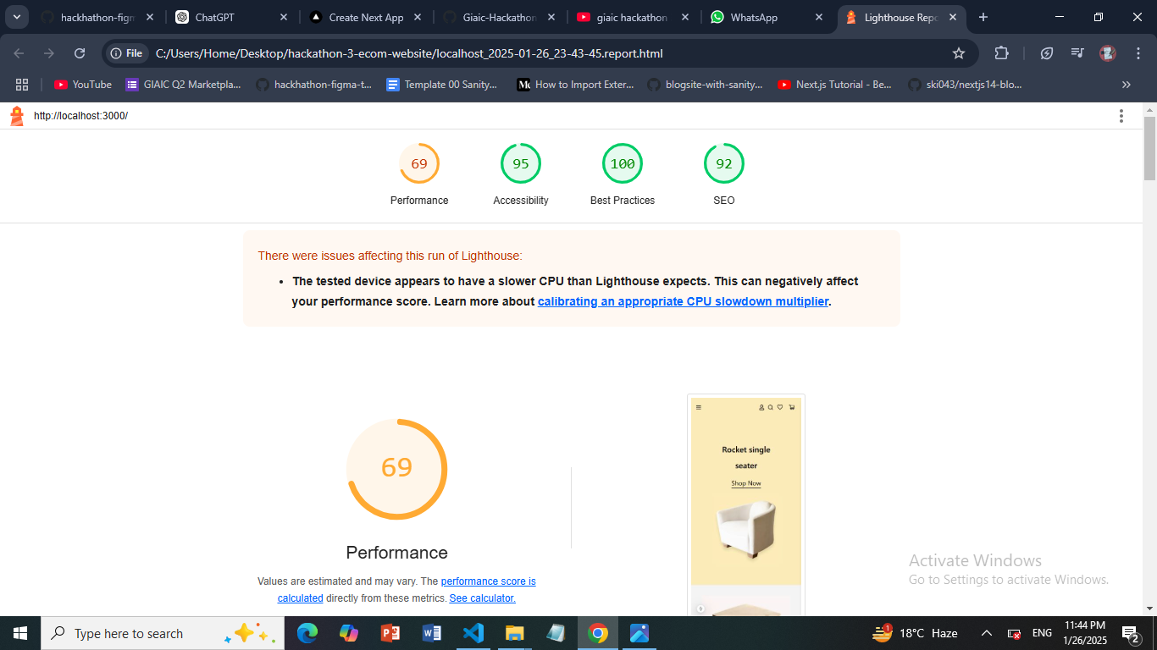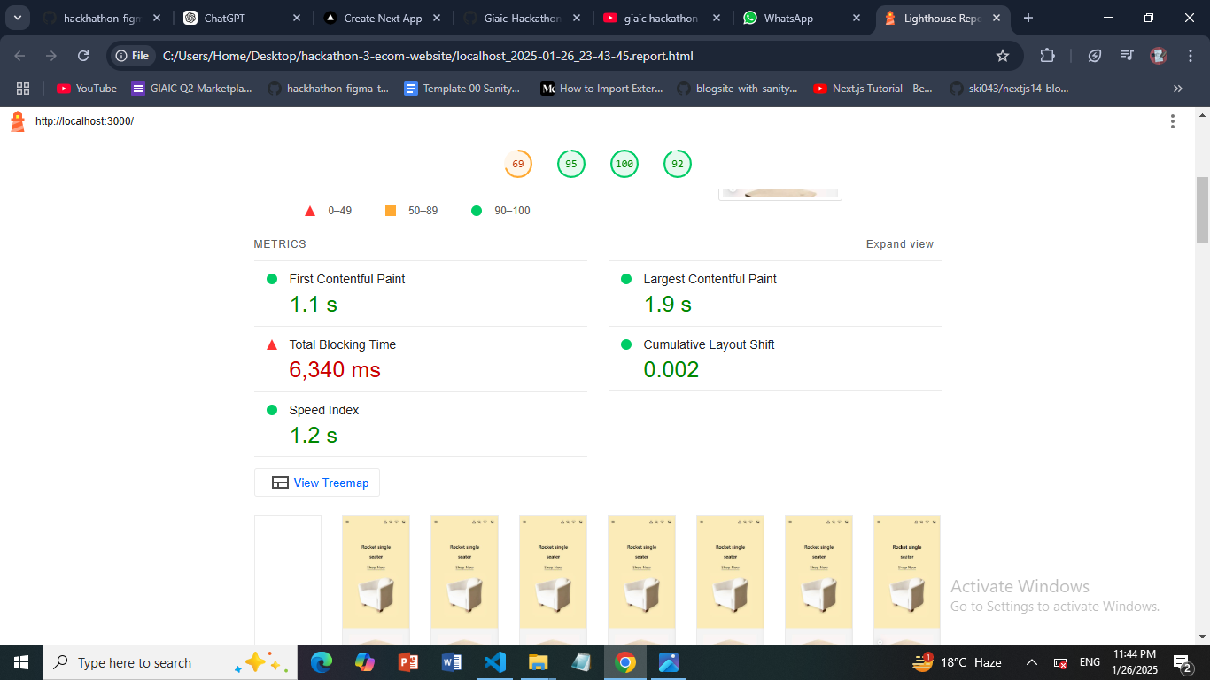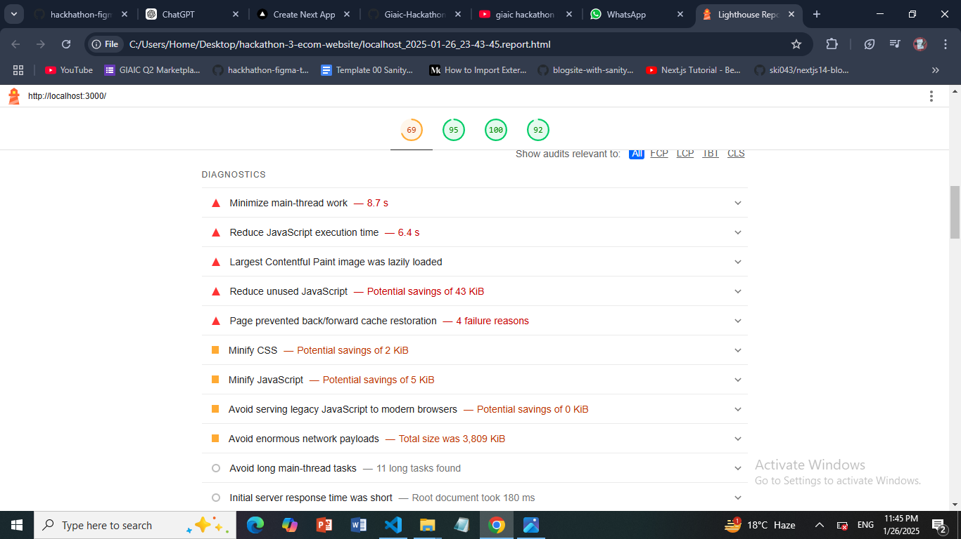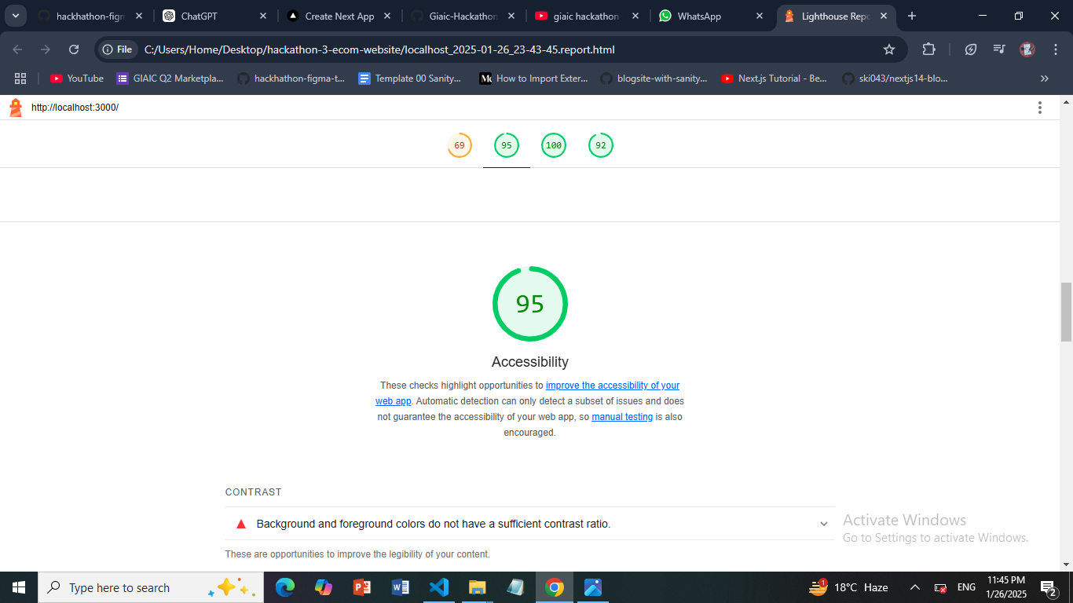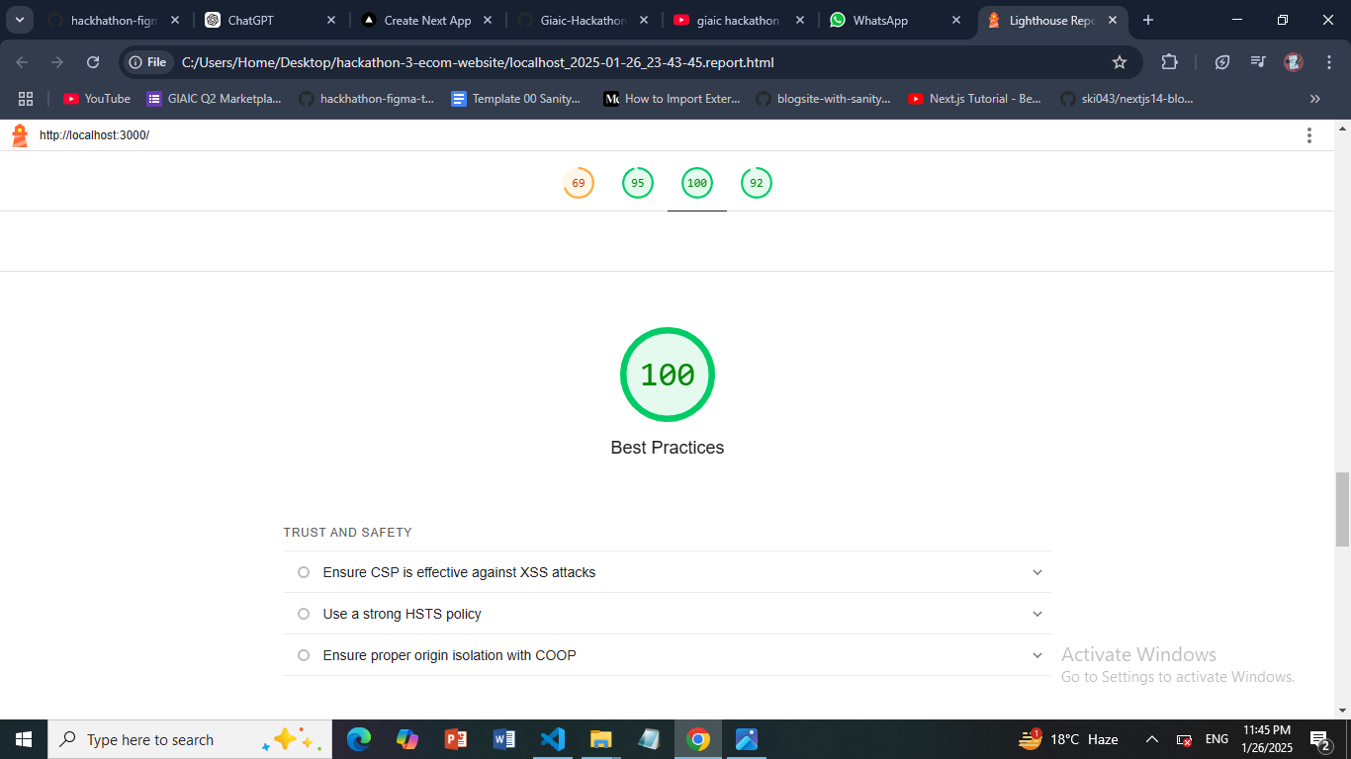

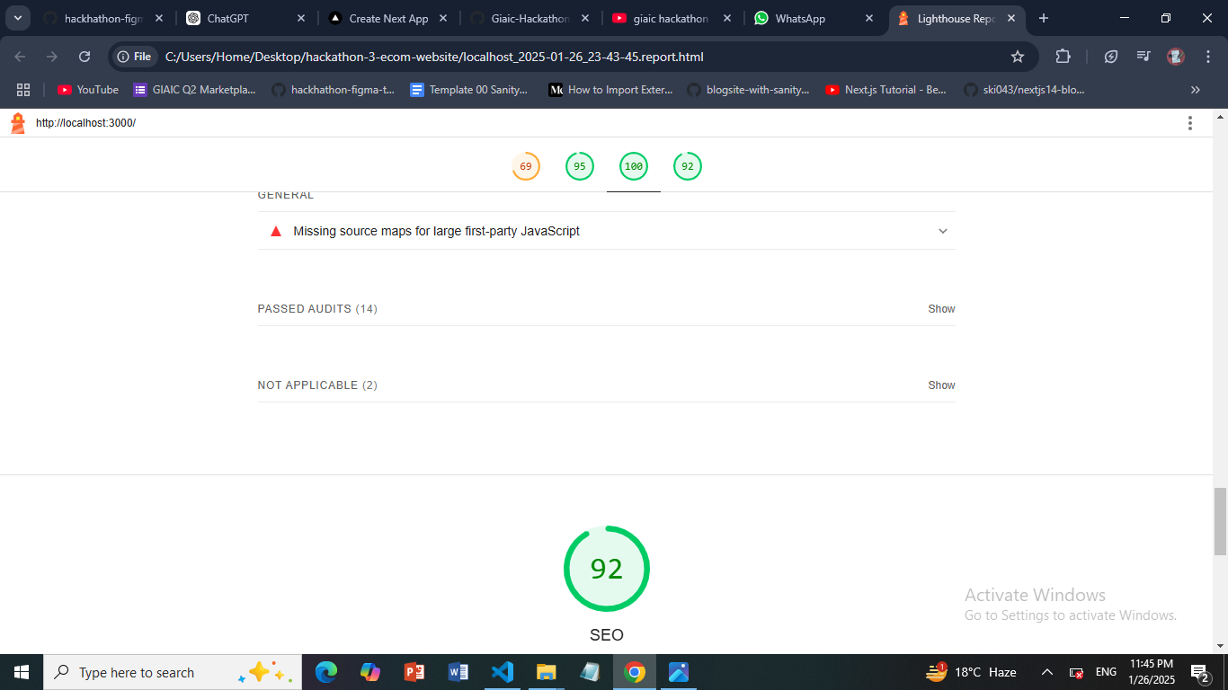

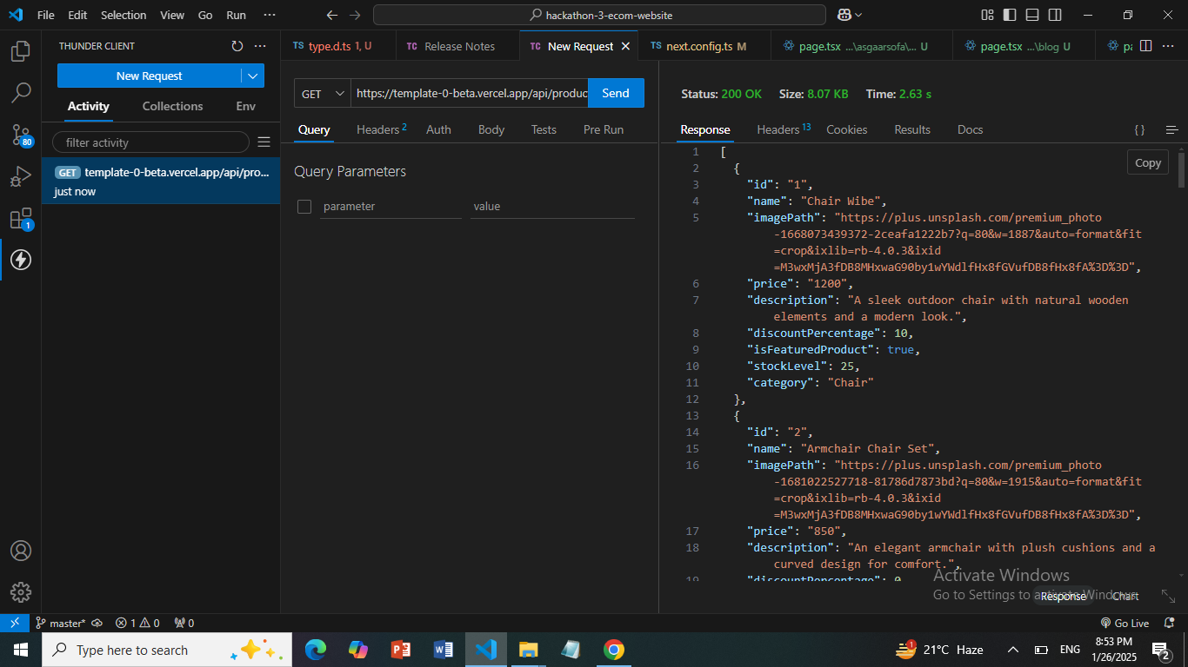

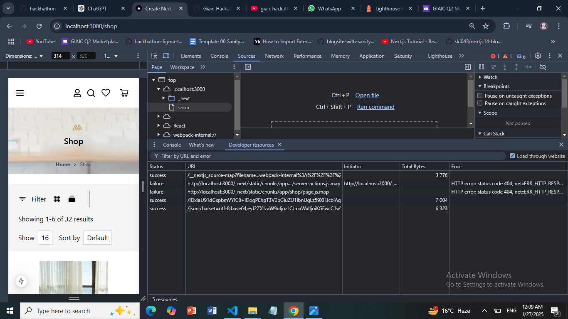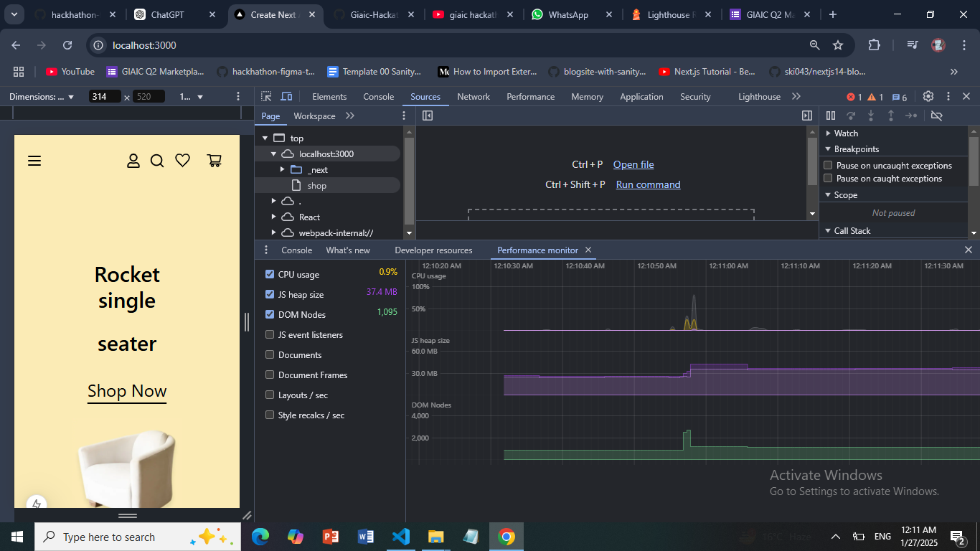

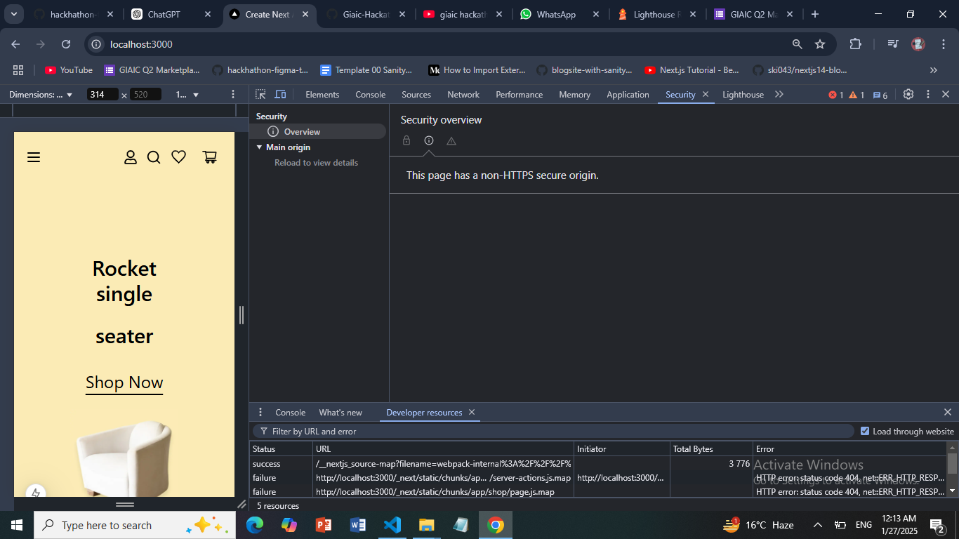

**Test Case Report:**

|  |  |  |  |  |  |  |  |  |  |
| --- | --- | --- | --- | --- | --- | --- | --- | --- | --- |
| Test Case ID | Test Case Description | Test Steps | Expected Result | Actual Result | Status | Severity Level | Assigned To | Remarks |  |
| TC001 | Validate product listing page | Open product page > Verify products | Products displayed correctly | Products displayed correctly | Passed | Low | - | No issues found | |
| TC002 | Test API error handling | Disconnect API > Refresh page | Show fallback UI with error message | Error message shown | Passed | Medium | - | Handled gracefully | |
| TC003 | Check cart functionality | Add product to cart > Verify cart contents | Cart updates with added product | Cart updates as expected | Passed | High | - | Works as expected | |
| TC004 | Ensure responsiveness on mobile | Resize browser window > Check layout | Layout adjusts properly to screen size | Responsive layout working as intended | Passed | Medium | - | Test successful | |
|  |  |  |  |  |  |  |  |  |  |